Language Supports
Said | Meant | Mattered
- - According to the image/source, ___.  - - ___ was/had/looked like ___.  - - ___ was explaining the ___.  - - This source clarified why the ___.  - - In this source/quote/excerpt, the author proposed ___. | - - The evidence pointed to ___.  - - ___ would have a negative/positive impact  because ___  - - ___ proved ___ because ___.  - - This image implied ___. | - - ___ was important because ___.  - - ___ was significant due to ___ .  - - This evidence demonstrated how ___.  - - An examination of this image revealed ___.  - - This image models the author’s use of ___.

Explain Your Evidence
Source | What does the text SAY? | What does the evidence MEAN? | Why does it MATTER?
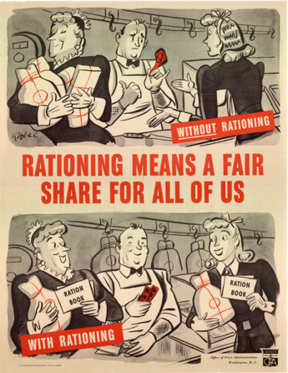 | The image at the top of the poster featured two women at the butcher, one clearly claiming more than her fair share.  The image at the bottom of the poster featured the same two women. Each woman is holding a ration book, the butcher is holding ration stamps, and each woman holds the same amount of food. | The two contrasting images in this poster represented the experience of rationing during World War II. The image at the top was meant to represent what the experience would be like without rationing, whereas the image at the bottom of the poster features the same two women, but with ration books and the same amount of food. | The WWII propaganda is important because it not only showed the importance of rationing during wartime America, but also demonstrated how women contributed to the war effort by partaking in government programs at home.
Source | What does the text SAY? | What does the evidence MEAN? | Why does it MATTER?

