Virtual Contest Guide

2020-2021 School Year

National History Day learned quickly when COVID-19 hit during the 2020 contest year how to adapt to a virtual contest format. To make this year even better, we took lessons learned from last season’s virtual contests and a committee of teachers, students, judges, and state coordinators developed uniform project guidelines for all virtual contests. Standard procedures match across the country to keep contests fair and to help students transition between contest levels.

All NHD in Idaho contests will be virtual in the 2020-21 school year. The following instructions guide participants on how to create their projects so that they can be easily submitted for contests when registration begins.

If there are questions about any of these guides, or problems accessing the templates through the links, please contact the NHD in Idaho Coordinators:

Johanna Bringhurst
208-780-5190
Johanna.Bringhurst@ishs.idaho.gov
Ben Knapp
208-780-5191
Ben.Knapp@ishs.idaho.gov

Don’t Forget! There is a new Rule Book for this school year!
No matter what category a student chooses, they should read the new rule book to follow their category rules. The new 2021 Rule Book is available for download here: https://www.nhd.org/sites/default/files/NHDRuleBook2021Digital.pdf.

Choosing Between Group and Individual Projects
NHD is not putting any restrictions on group projects for the 2020-21 school year. Students can still choose to work as individuals in all categories or work in groups of 2-5 students in the website, documentary, exhibit, and performance categories. The historical paper category is still only for individuals. If students choose to work in a group and meet in-person, they should follow health and safety guidelines from their school, city, county, and state.

Instructional Guides by Category

Historical Papers page 2
Websites page 2
Documentaries page 3
Exhibits page 5
Performances page 8

Historical Papers

- Rules: Paper category students should review the new 2021 NHD Rule Book to ensure they do not miss any important rules and requirements for their category.

- Formatting:
  - Once the student has finalized their paper, they should combine all required parts into one PDF file that contains the title page, process paper, Historical Paper and annotated bibliography in that order. The registration system only allows one PDF upload, so it must include all required paperwork.
  - Combine multiple PDFs into one. There are some free online apps available such as Small PDF and I Love PDF.
  - Watch to learn how to combine PDF documents into one PDF file: https://www.youtube.com/watch?v=VunwovyV0dI&feature=youtu.be
  - Paperwork should be in this order: the title page, process paper, and annotated bibliography.
  - They should save the final version as one PDF file with their first and last names, followed by the contest level. For example, John Smith should save his regional contest paper as johnsmithregional.pdf. If he qualifies for the state contest, he should save his state contest paper as johnsmithstate.pdf.

- Virtual Contest Submission: Students will be required to upload their final PDF file to the contest registration system by the registration deadline - separate contest registration instructions to follow closer to the contests.

Websites

- Rules: Website category students should review the new 2021 NHD Rule Book to ensure they do not miss any important rules and requirements for their category. Please remember that NHDWebCentral (https://website.nhd.org/) must be used to build and create ALL websites. Complete instructions are available in the new NHDWebCentral Guide.

- Formatting: As detailed in the rules, students should include their process paper and annotated bibliographies on their website.

- Virtual Contest Submission: During registration, students will provide their website’s 8-digit code found in its URL - separate contest registration instructions will follow closer to the contests.

- Important contest planning note! Websites are unable to be edited during the contest. They will “freeze” at 11:59 p.m. on the registration deadline and not unfreeze until after the contest.

Documentaries

- Rules: Documentary category students should review the new 2021 NHD Rule Book to ensure they do not miss any important rules and requirements for their category.

- Formatting: Documentary students need to plan to upload a shareable .MP4 video file of their final project to Google Drive, One Drive, or DropBox by the contest registration deadline. Students should prepare to give themselves plenty of time to complete this process before the deadline. Files typically upload faster over a wired connection instead of WiFi. Documentary students also need to save their paperwork as one PDF file and upload it to the registration system by the deadline - separate contest registration instructions will follow closer to the contests.

- Virtual Contest Submission:

Step 1: Create one PDF file that contains the title page, process paper, and annotated bibliography in that order. The registration system only allows one PDF upload, so it must include all required paperwork.
- Combine exhibit PDF and required paperwork into a single PDF file.
- Combine multiple PDFs into one. There are some free online apps available such as Small PDF and I Love PDF.
  - Watch to learn how to combine PDF documents into one PDF file: https://www.youtube.com/watch?v=VunwovyV0dI&feature=youtu.be
- Paperwork should be in this order: the title page, process paper, and annotated bibliography.
- If competing as an individual, name the file with first and last name and the contest level. For example: johnsmithregional.pdf at the regional contest level or johnsmithstate.pdf at the state contest level.
- If competing as a group, name the file with each group member’s last name and the contest level. For example: smithjonesthomasregional.pdf at the regional contest level or smithjonesthomasstate.pdf at the state contest level.

Step 2: Upload the .MP4 file of the documentary to Google Drive, One Drive, or DropBox. A particular platform is not preferred as long as it is viewable to anyone with the link. If you do not have access to one of these shareable drives or have a way to share outside access to your file in a school drive, please email johanna.bringhurst@ishs.idaho.gov before your contest deadline so that she can assist.
- If competing as an individual, name the .MP4 file with first and last name and the contest level. For example: johnsmithregional.mp4 at the regional contest level or johnsmithstate.mp4 at the state contest level.
- If competing as a group, name the file with each group member’s last name and the contest level. For example: smithjonesthomasregional.mp4 at the regional contest level or smithjonesthomasstate.mp4 at the state contest level.

Step 3: Make Google Drive, One Drive, or DropBox Link Shareable. See the following instructions for each platform.

DropBox Share Steps
Upload file to DropBox. Once uploaded, hover over the .MP4 file and click the Share button. A pop-up box will appear. Find “Share a link instead,” create a link, and set it to “Anyone with a link can view.” Copy the link.

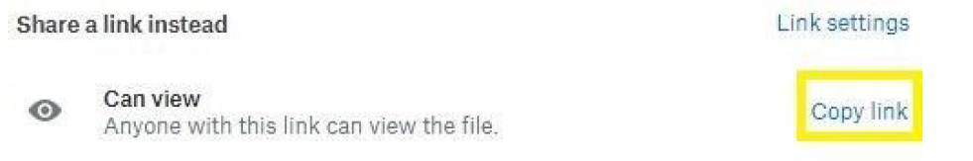

Google Drive Share Steps
Upload file to Google Drive. Once uploaded, right-click on the file. Select the “Share” option from the menu. A pop-up box will appear, as shown below. Make sure “Anyone on the internet with this link can view” is selected. If not, click on the blue change button and select that option. Once set to “Anyone” click on “copy link” and done.

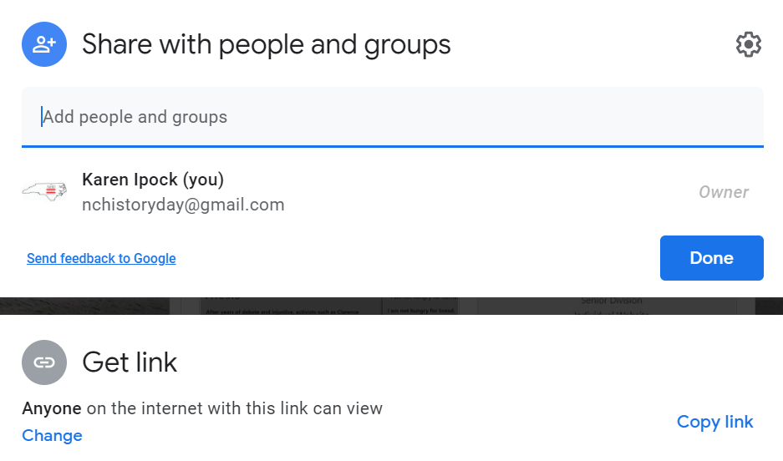

One Drive Share Steps
Upload file to One Drive. Once uploaded, right-click on the file. Select the “Share” option from the menu. Change settings to “Anyone with the link can view.” Copy the link.
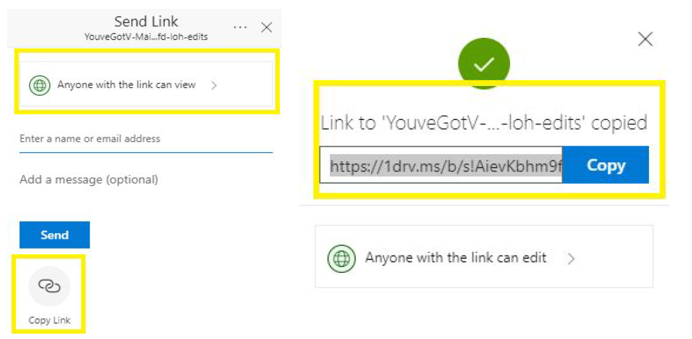
Step 4: Double-check that contest coordinators and judges can access shareable link. Open an incognito browser tab (directions below) and copy and paste the link there. If the video is not shared, repeat Step 3. If the video appears, advance to Step 5.
- How to Open Incognito Browser Tab
  - Windows, Linux, or Chrome OS: Press Ctrl + Shift + n.
  - Mac: Press ⌘ + Shift + n.

Step 5: Submit project to the contest by the contest registration deadline. Using the separate registration instructions (sent out closer to the contest), make sure to register for the contest by the registration deadline. Include the documentary’s shareable link and upload paperwork’s PDF file during the registration process.

- Important contest planning note! Make sure that the documentary stays on the shareable drive and does not change locations or settings during the contest. The contest runs from the close of registration through to the announcement of finalists.

Exhibits

- Rules: Exhibit category students should review the new 2021 NHD Rule Book to ensure they do not miss any important rules and requirements for their category.

- Formatting: Traditionally, an NHD exhibit sits on a table for judging. However, this year, there are two options:
- Physically construct an exhibit and then take photos of it and follow the guidelines for virtual contest submission.
- Create a virtual exhibit and follow these guidelines for virtual submission.

- Special Considerations: Because all contests will be virtual this year, please consider the following issues:
- Please remember that exhibit rules still apply for both physical and virtual exhibits.
- Although, the NHD Contest Rule Book allows exhibit students to include a multimedia device in exhibit, include supplemental materials on the tabletop, and to create an exhibit other than a tri-fold board that rests on a tabletop, this year NHD strongly recommends that students create a simpler exhibit -- a tri-fold board without the extras. Photographed or virtually created exhibits cannot adequately represent physical exhibits that are round, multi-sided, or those with moving parts.

- Virtual Contest Submission: Follow the instructions below for creating a physical exhibit OR a virtual exhibit.

Guidelines for Creating a Physical Exhibit and

Submitting it to a Virtual Contest

If students create a physical exhibit, they must photograph their exhibit and use the template below to submit to the virtual contests.

Step 1: Create a set of slides that include the following:
  - a full photo of the exhibit, and
  - photographed sections of the exhibit with accompanying text.
Use either of the two template options to submit an exhibit. These options provide students with slides to insert photos and text from their exhibit. Students may not add additional slides. More details are on the first page of either slide template.
  - Google Slides Template:
https://docs.google.com/presentation/d/1ZcwePJogjrxbxFwgtTyZVMxXY23VpyM5TL08OpGB9Y8
  - PowerPoint Template:
https://docs.google.com/presentation/d/14LkQ6mav8kMw8gtXuH9wC3LUWjFAC0dS

View a sample project submitted through one of these templates here: https://drive.google.com/file/d/1F3xQQ2H45It5IQZpJWNuaTBCw4dL7WWq/view

Step 2: Prepare to submit slides and required paperwork:
- Export/download completed exhibit template as a PDF.
- Combine exhibit PDF and required paperwork into a single PDF file.
- Combine multiple PDFs into one. There are some free online apps available such as Small PDF and I Love PDF.
  - Watch to learn how to combine PDF documents into one PDF file: https://www.youtube.com/watch?v=VunwovyV0dI&feature=youtu.be
- Paperwork should be in this order: the title page, process paper, annotated bibliography, exhibit template.
  - Please see this example for the correct order: https://drive.google.com/file/d/1eifpfDehiQzOHvIE98T1ZJpUnT_lxpTh/view
  - Please see this video to learn how to combine PDF documents into one PDF file: https://www.youtube.com/watch?v=VunwovyV0dI&feature=youtu.be.

Step 3: Submit project to the contest by the contest registration deadline. Using the separate registration instructions (sent out closer to the contest), make sure to register for the contest by the registration deadline. Upload the combined PDF during the registration process.

Guidelines for Creating a Virtual Exhibit and
Submitting it to a Virtual Contest

Instead of building a physical exhibit, create an exhibit with design software. Virtual exhibits must still comply with all category rules, including word count and maximum size.

Step 1: Create a Virtual Exhibit
- To create a virtual exhibit, students may use any design software they prefer. Here are two examples:
  - Google Drawings is a free program that allows students to create a virtual exhibit within the maximum NHD exhibit size limit. Using this program does require creating a free Google account if participant does not already have one.
  - Microsoft Publisher is another program that students may have access to through their school. This program also allows students to create a virtual exhibit that fits within the maximum NHD exhibit size limit.
  - Google Slides is a free program that allows students to create a virtual exhibit within the framework of a slideshow created by 20 in x 20 in slides. Using this program does require creating a free Google account if participant does not already have one.
- A 74-inch wide x 72-inch high page size replicates the maximum dimensions of a tri-fold exhibit. A standard rules-compliant tri-fold board laid flat is 74-inches wide by 72-inches high. Students can make size adjustments, but they cannot be larger than these dimensions.
- The minimum font size on a virtual exhibit is 20 pt font.
- Here are three optional templates:
  - Google Drawings NHD Template (74-inch wide x 72-inch high):
https://docs.google.com/drawings/d/1t3kKf3_HtkDc7DkGadlcwjjg5rK9BVFFZA56XnFByow/template/preview
  - Microsoft Publisher NHD Template (74-inch wide x 72-inch high):
https://drive.google.com/file/d/1Id2h182pVtm6GEii29HbsfqXwpKCqZAb/view
- Google Slides/Microsoft PowerPoint NHD Template (20 in x 20 in slides):
https://docs.google.com/presentation/d/1J74K3zTIsXuPs364vuGv8EbDZLtU_4m-EQJDB1EeWC8
All of the templates are adjustable. Students may make the virtual exhibit smaller, but they may not make the dimensions larger. Students may adjust or eliminate the black lines on the templates if desired.
  - View a sample project in the Google Drawing or Microsoft Publisher template: https://drive.google.com/file/d/1O_lcTDo5Kw-Rl_Xt9vHU6lLIceFo9_kt/view
  - View a sample project in the Google Slides or Microsoft PowerPoint template:
https://drive.google.com/file/d/1Zr7JkzJiV2nMGcSwPgiKenvU35GC1xR/view?usp=sharing
- Regardless of which design software students use, NHD strongly recommends designing a tri-fold exhibit. Virtually created exhibits cannot adequately represent physical exhibits that are round, multi-sided, or those with moving parts.

Step 2: Prepare to submit virtual exhibit and required paperwork:
- Export/download completed exhibit template as a PDF.
- Combine exhibit PDF and required paperwork into a single PDF file.
- Combine multiple PDFs into one. There are some free online apps available such as Small PDF and I Love PDF.
  - Watch to learn how to combine PDF documents into one PDF file: https://www.youtube.com/watch?v=VunwovyV0dI&feature=youtu.be
- Paperwork should be in this order: the title page, process paper, annotated bibliography, exhibit template.
- View an example of the final exhibit paperwork order here: https://drive.google.com/file/d/1eifpfDehiQzOHvIE98T1ZJpUnT_lxpTh/view
- Save the final combined PDF file using these naming guidelines:
  - If competing as an individual, name the file with first and last name and the contest level. For example: johnsmithregional.pdf at the regional contest level or johnsmithstate.pdf at the state contest level.
  - If competing as a group, name the file with each group member’s last name and the contest. For example: smithjonesthomasregional.pdf at the regional contest level or smithjonesthomasstate.pdf at the state contest level.

Step 3: Submit project to the contest by the contest registration deadline. Using the separate registration instructions (sent out closer to the contest), make sure to register for the contest by the registration deadline. Upload the combined PDF during registration.

Performances

- Rules: Performance category students should review the new 2021 NHD Rule Book to ensure they do not miss any important rules and requirements for their category. Please remember that performance rules still apply for virtual contests.

- Formatting: Choose this category carefully! This category requires students to record their performance and upload it into a shareable online drive for judges to view. Last year accommodations were made since projects were already underway when the contests had to go virtual. This year recordings are required to be submitted in order to compete.

- Virtual Contest Submission: For this year’s unique contest season, NHD has created guidelines for submitting performances with health and safety measures in mind. If you qualify for the national contest, you will have to submit a required “performance companion worksheet” to accompany the performance paperwork. This worksheet will not be required for regional or state contests. See the instructions below for creating a script, recording your performance, and finalizing your paperwork and performance for contest registration.

Performance Script and Paperwork Guidelines

Your performance script assists judges in understanding the historical argument you are making in your performance and ensures that if they have trouble hearing your recording well, they can still read your script. Here are the links to the important documents:
- Performance Script Template:
https://docs.google.com/document/d/1yp4gtS3ocaIdC9o_0b0ydJPiJnEbI1NOlKQMciYwa1Q
- Performance Script Example
https://docs.google.com/document/d/1i5l7YP0tFW58co3BE94hFlo1gJzwl2D1fmfKQFsj20A

Performance Recording Guidelines

There are two options for recording performances. Students can film their performance the traditional way using a camera or phone or use an online conferencing platform such as Google Meet, Zoom, and Microsoft Teams. These platforms are only recommendations. Students are free to use any platform their teacher deems appropriate. Here are the requirements and notes for both options:
- Students should follow all social distancing guidelines and preventative actions that apply in their school, city, county or state. NHD encourages group performances to consider using an online conferencing platform to record their performance to help everyone stay safe and healthy.
- Students can utilize their backgrounds and props, wear any relevant costumes, and get creative. If using one of the online platforms, students can consider virtual backgrounds and other digital effects.
- Any audio recordings, music, or media should be present in the recording as a part of the performance.
- Students must record performances in one continuous take regardless of if recorded the traditional way or students use an online platform. Participants are not allowed to edit multiple clips together.
- If recording with a phone or camera, the equipment should be stationary and from the point of view of where the audience would be sitting. Make sure the camera does not pan or zoom.
- A teacher or parent may assist with recording a performance.
- Students want to be sure there is not the appearance of editing. This is particularly important if using an online platform to record. Remember, if the app switches views, it might appear as an edit even if it is a continuous take. A way to prevent this is for individual performers to make sure they stay in camera view (even partially) the entire performance. For groups, be sure that all performers’ screens are visible throughout the performance, even if minimized at the bottom. That way, the platform cutting between screens does not appear to be an editing cut.
- Once performance recording is ready, save the file as an .MP4.
- Make sure the performance volume is clear! If the performance is hard to hear, the judges might miss important points. If there are parts that are not clear, consider redoing the recording.

Final Steps for Preparing Performance Recording
and Paperwork for Contest

- Finalizing Performance Paperwork for Registration
- When it comes time to submit the performance during registration, combine all the performance paperwork into one PDF document. The registration system only allows one PDF upload.
- Combine multiple PDFs into one. There are some free online apps available such as Small PDF and I Love PDF.
- Paperwork should be in this order: Title Page, Process Paper, Script and Annotated Bibliography.
- Save the final combined PDF file using these naming guidelines:
  - If competing as an individual, name the file with first and last name and the contest level. For example: johnsmithregional.pdf at the regional contest level or johnsmithstate.pdf at the state contest level.
  - If competing as a group, name the file with each group member’s last name and the contest. For example: smithjonesthomasregional.pdf at the regional contest level or smithjonesthomasstate.pdf at the state contest level.

- Finalizing Performance Recording for Registration
- Students should plan to upload their final performance recording as a shareable .MP4 video file on Google Drive, One Drive, or DropBox by the contest registration deadline.
- Students need to give themselves plenty of time to complete this process before the deadline. Files typically upload faster over a wired connection instead of WiFi.
- To prep recording for submission, please follow these steps:

Step 1: Upload the .MP4 file of performance to Google Drive, One Drive, or DropBox. There is no preference on which platform as long as your performance recording is viewable to anyone with the link. If you do not have access to one of these shareable drives or have a way to share outside access to your file in a school drive, please email johanna.bringhurst@ishs.idaho.gov before your contest deadline so that she can assist.
- If competing as an individual, name the .MP4 file with first and last names and the contest level. For example: johnsmithregional.mp4 at the regional contest level or johnsmithstate.mp4 at the state contest level.
- If competing as a group, name the file with each group member’s last name and the contest level. For example: smithjonesthomasregional.mp4 at the regional contest level or smithjonesthomasstate.mp4 at the state contest level.

Step 2: Make Google Drive, One Drive, or DropBox link shareable when ready to register. Complete this step when ready to submit the project link during registration. See the instructions below for each platform to see how to get a shareable link.

DropBox Share Steps
Upload file to DropBox. Once uploaded, hover over the .MP4 file and click the Share button. A pop-up box will appear. Find “Share a link instead,” create a link, and set it to “Anyone with a link can view.” Copy the link.

Google Drive Share Steps
Upload file to Google Drive. Once uploaded, right-click on the file. Select the “Share” option from the menu. A pop-up box will appear, as shown below. Make sure “Anyone on the internet with this link can view” is selected. If not, click on the blue change button and select that option. Once set to “Anyone” click on “copy link” and done.

One Drive Share Steps
Upload the file to One Drive. Once uploaded, right-click on the file. Select the “Share” option from the menu. Change settings to “Anyone with the link can view.” Copy the link.

Step 3: Double-check that contest coordinators and judges can access the shareable link. Open an incognito browser tab (directions below) and copy and paste the link there. If the video is not shared, repeat Step 2. If the video appears, advance to Step 4.
      - How to Open Incognito Browser Tab:
        - Windows, Linux, or Chrome OS: Press Ctrl + Shift + n.
        - Mac: Press ⌘ + Shift + n.

Step 4: Submit project to the contest by the contest registration deadline. During registration, include the performance’s shareable link and upload the PDF file of combined paperwork (Title Page, Process Paper, Script, and Annotated Bibliography).

Important contest planning note! Ensure that the performance recording stays on the shareable drive and does not change locations or settings during the contest. The contest runs from the close of registration through to the announcement of finalists.

