Inadvertent Discovery Plan
  - The Inadvertent Discovery Plan (IDP) protocol must be adhered to if cultural materials, including human remains, are encountered during construction
Project: Click or tap here to enter text.
SHPO Review No.: Click or tap here to enter text.
Project Manager: Click or tap here to enter text.
Location: Click or tap here to enter text.

Cultural Resources
Construction work may uncover previously unidentified Native American or Euro-American artifacts. This could occur for a variety of reasons, but may be associated with deeply buried cultural material, access restrictions during project development, or if the area contains impervious surfaces throughout most of the project area which would have prevented standard archaeological site discovery methods. Work must stop and the IDP protocol followed when archaeological artifacts and/or features are encountered.
Native American artifacts may include (but are not limited to):
- Flaked stone tools (e.g. arrowheads, knives scrapers etc.);
- Waste flakes that resulted from the construction of flaked stone tools;
- Modified, shaped, or perforated stones like net anchors, pendants;
- Ground stone tools like mortars and pestles;
- Layers (strata) of discolored earth resulting from fire hearths. May be black, red or mottled brown and often contain discolored cracked rocks or dark soil in association with other artifacts;
- Human remains; and/or
- Structural remains (e.g. wooden beams, post holes, fish weirs).
Euro-American artifacts may include (but are not limited to):
- Glass (e.g. bottles, vessels, windows etc.);
- Ceramic (e.g. dinnerware, vessels etc.);
- Metal (e.g. nails, drink/food cans, tobacco tins, industrial parts etc.);
- Building materials (e.g. bricks, shingles etc.);
- Building remains (e.g. foundations, architectural components etc.);
- Old wooden posts, pilings, or planks (these may be encountered above or below water);
- Old farm equipment may indicate historic resources in the area.
Even what looks to be old garbage could very well be an important archaeological resource.
When in doubt, call it in!

Protocol

Stop Work Immediately
In the event of an inadvertent discovery of possible cultural materials, including human remains, all work will stop immediately in the vicinity of the find. The area will then be secured and protected with a 100-foot buffer around the discovery. Work can proceed outside of this buffered area unless additional cultural materials are encountered.

Special Procedures for the Discovery of Human Skeletal Material
Any human skeletal remains, regardless of antiquity or ethnic origin, will always be treated with dignity and respect. Cover the remains with a tarp or other materials (not soil or rocks) for temporary protection and to shield them from being photographed. Do not call 911 or speak with the media. Do not take pictures.

Notify Appropriate Parties
The project manager must be notified immediately, who will then notify the State Historic Preservation Office (SHPO), the local police or sheriff’s department, and the project Archaeologist, as appropriate.
If potential human remains are encountered, the local police or sheriff’s department must be notified and they will coordinate with the Idaho State Police (ISP), the local Medical Examiner/Coroner, and appropriate Tribal Governments. Call the non-emergent line and request the Watch Commander or Officer-In-Charge.

Project Manager  Name: Click or tap here to enter text.  Phone: Click or tap here to enter text.  Email: Click or tap here to enter text. | Project Archaeologist  Name: Click or tap here to enter text.  Phone: Click or tap here to enter text.  Email: Click or tap here to enter text.
State Historic Preservation Office  Name: Lindsay Johansson  Phone: 208.334.3861  Email: shsshpo@ishs.idaho.gov | City/County Project Manager  Name: Click or tap here to enter text.  Phone: Click or tap here to enter text.  Email: Click or tap here to enter text.
Local Law Enforcement  Name: Click or tap here to enter text.  Phone: Click or tap here to enter text.  Email: Click or tap here to enter text. | Local Medical Examiner/Coroner  Name: Click or tap here to enter text.  Phone: Click or tap here to enter text.  Email: Click or tap here to enter text.
State/Federal Project Manager  Name: Click or tap here to enter text.  Phone: Click or tap here to enter text.  Email: Click or tap here to enter text. | Landowner  Name: Click or tap here to enter text.  Phone: Click or tap here to enter text.  Email: Click or tap here to enter text.

Wait for Guidance
No work in the buffered area may resume until consultation has occurred. If a professional archaeologist is needed to assess the discovery, they will consult with the SHPO and appropriate Tribal Governments to facilitate determination of an appropriate course of action. Archaeological investigation or excavations may be required. Until a formal determination can be made, archaeological deposits discovered during construction will be assumed eligible for listing in the National Register of Historic Places and should be protected. The professional archaeologist and project manager, in consultation with SHPO and Tribal Governments, handles this on a case-by-case basis.

Proceed with Construction
Construction can proceed only after the proper archaeological inspections have occurred and environmental clearances are obtained if necessary and clearance has been received from all parties involved. This requires close coordination with SHPO and the Tribal Governments.
After an inadvertent discovery, some areas may be specified for close monitoring or ‘no work zones.’ Any such areas will be identified by the professional archaeologist to the Project Manager, and appropriate Contractor personnel. In coordination with the SHPO, the Project Manager will verify these identified areas and be sure that the areas are clearly demarcated in the field.

Confidentiality
This project and its employees, contractors, and subcontractors shall make their best efforts, in accordance with federal and state law, to ensure that its personnel keep the discovery confidential. The media, or any third-party member or members of the public are not to be contacted or have information regarding the discovery, and any public or media inquiry is to be reported to Click or tap here to enter text.. Prior to any release, the responsible agencies and Tribes shall consult on the amount of information, if any, to be released to the public.
As the designated representative for the project, I acknowledge that I have received this inadvertent discovery plan and will, to the best of my abilities, ensure that it is implemented appropriately.

____________________________________________________________
Name: Click or tap here to enter text. Date Click or tap here to enter text.
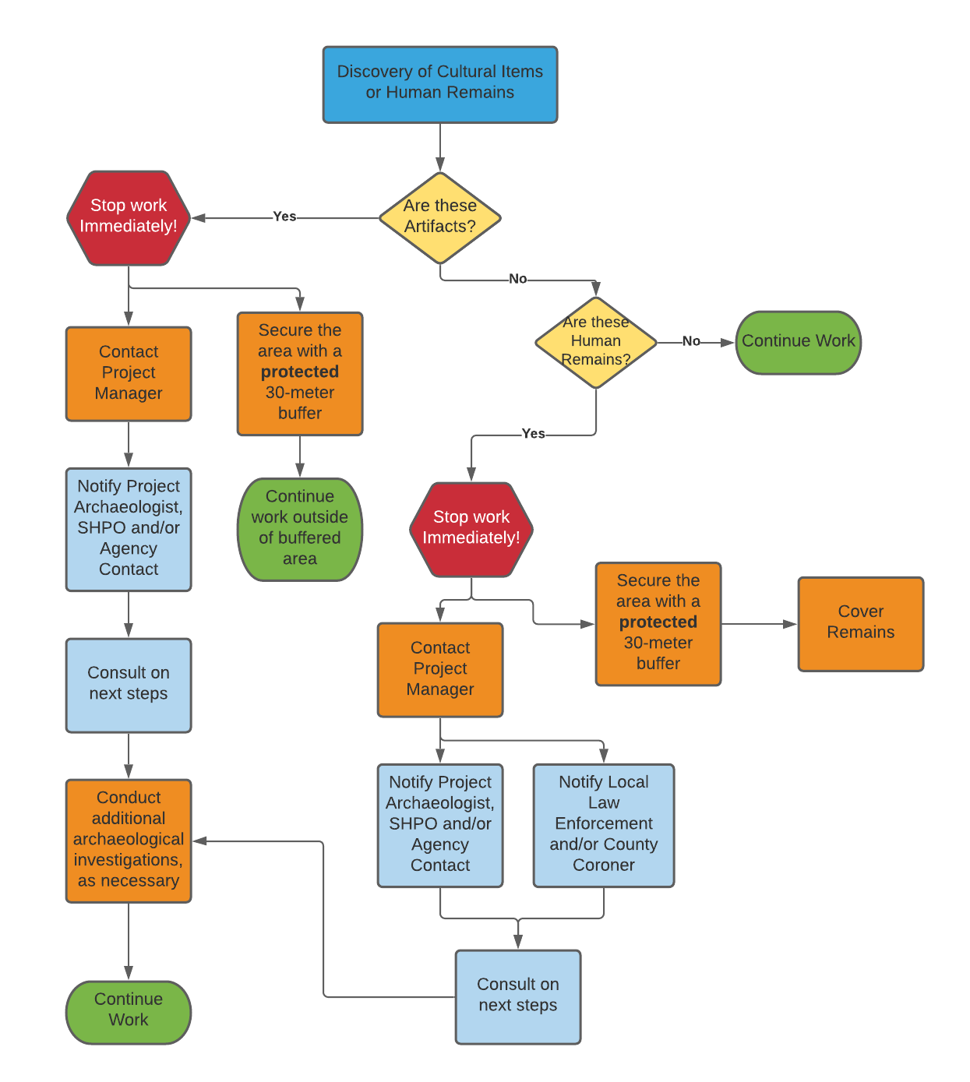
Appendix A: Process Flow Chart
Appendix B: Visual References and Examples of Potential Discoveries
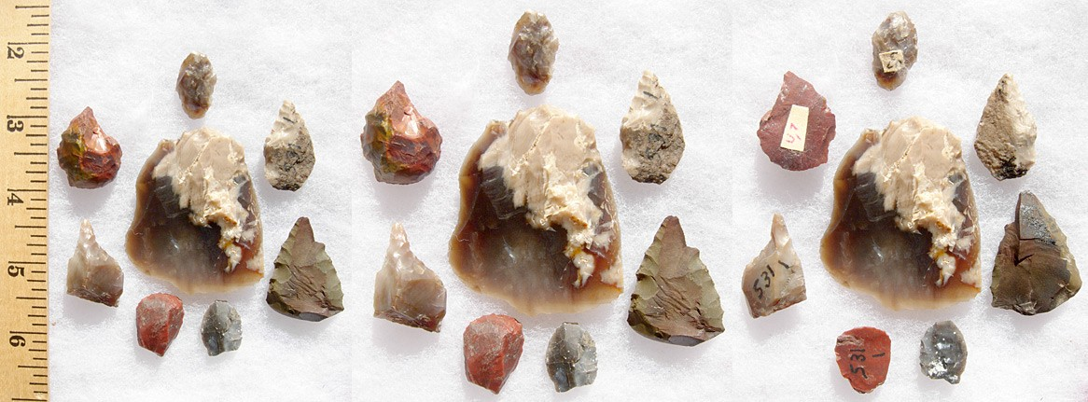
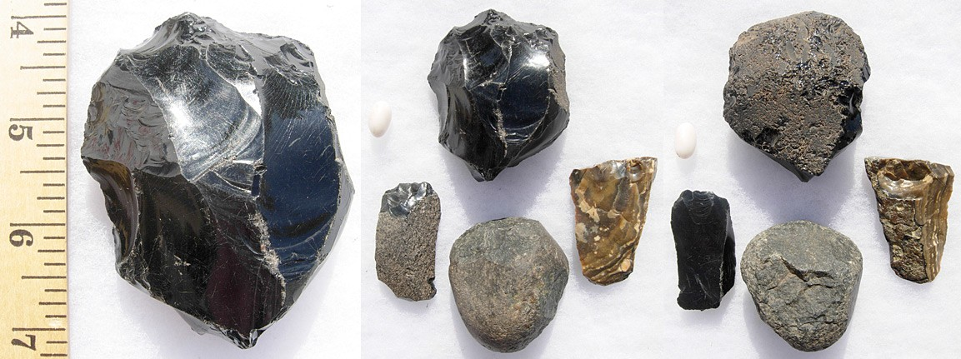
Implement the IDP if …
You see chipped stone artifacts.

- Glass-like material
- Angular
- “Unusual” material for area
- “Unusual” shape
- Regularity of flaking
- Variability of size

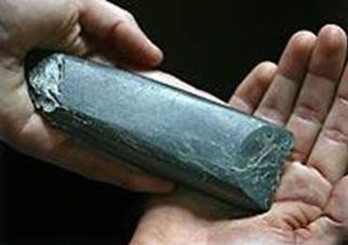
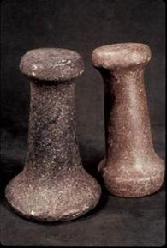
- Striations or scratching
- Unusual or unnatural shapes
- Unusual stone
- Etching
- Perforations
- Pecking
- Regularity in modifications
- Variability of size, function, and complexity
Implement the IDP if …
You see ground or pecked stone artifacts.

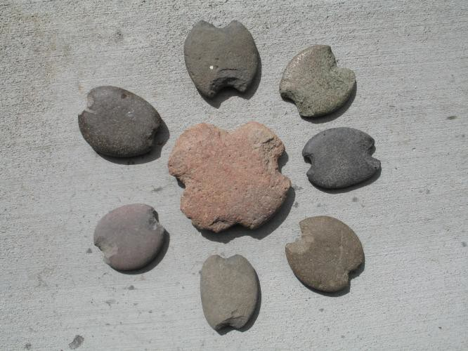
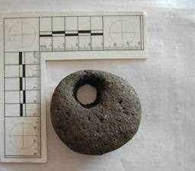
Stone Artifacts from Oregon
Artifacts from Unknown Proveniences
Implement the IDP if …
You see bone or shell artifacts.
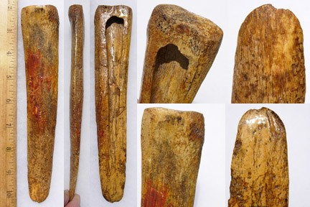
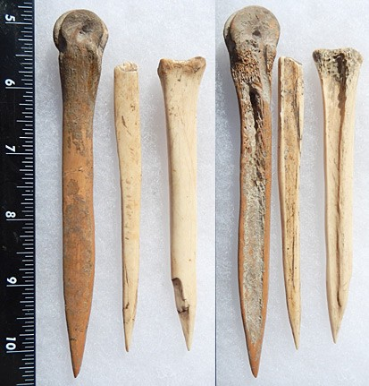
Bone Awls from Oregon and Bone Wedge from California
- Often smooth
- Unusual shape
- Carved
- Often pointed if used as a tool
- Often wedge shaped like a “shoehorn”
Implement the IDP if …
You see bone or shell artifacts.
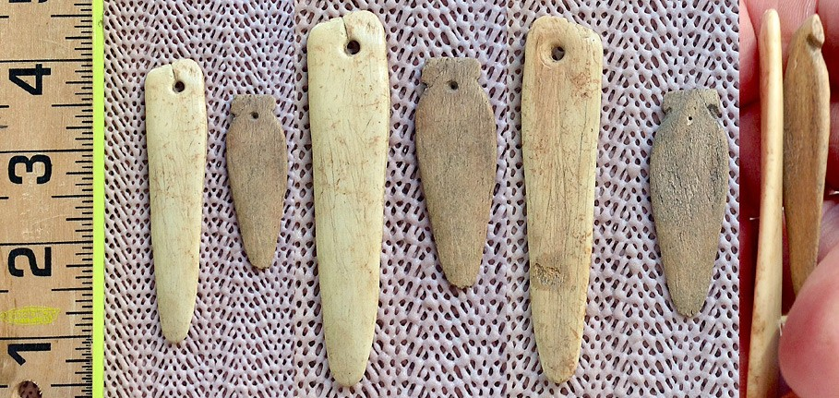
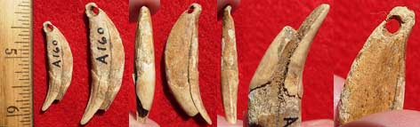
Tooth Pendant and Bone Pendants from Oregon and Washington
- Often smooth
- Unusual shape
- Perforated
- Variability of size
Implement the IDP if …
You see fiber or wood artifacts.
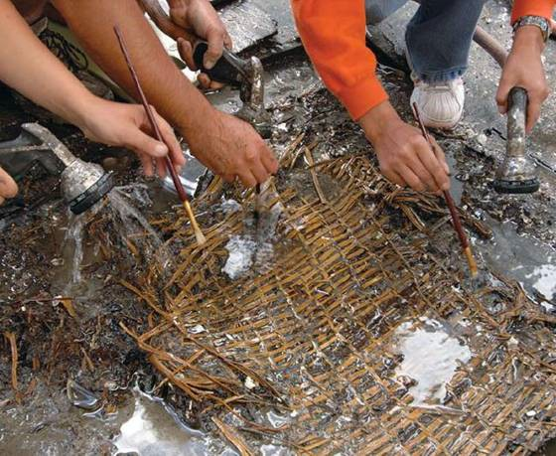
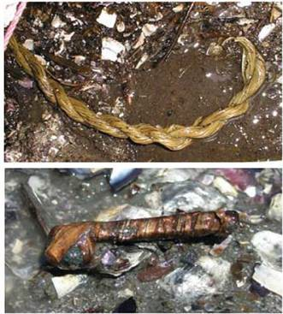
Artifacts by Mud Bay, Olympia, Washington
- Wet environments needed for preservation
- Variability of size, function, and complexity
- Rare
Implement the IDP if …
You see historic period artifacts.
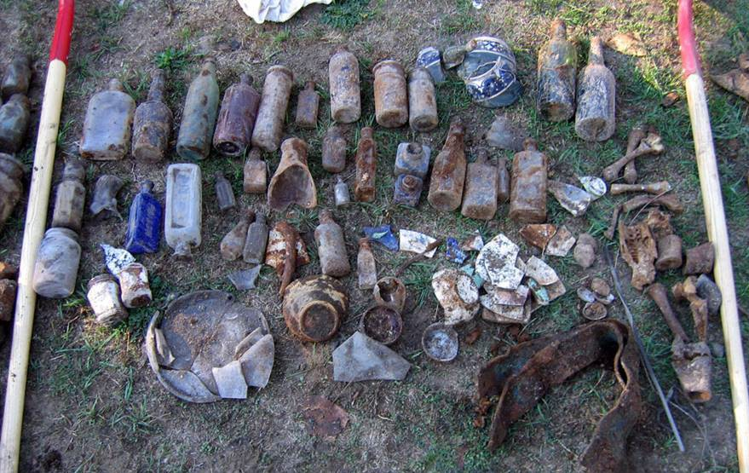
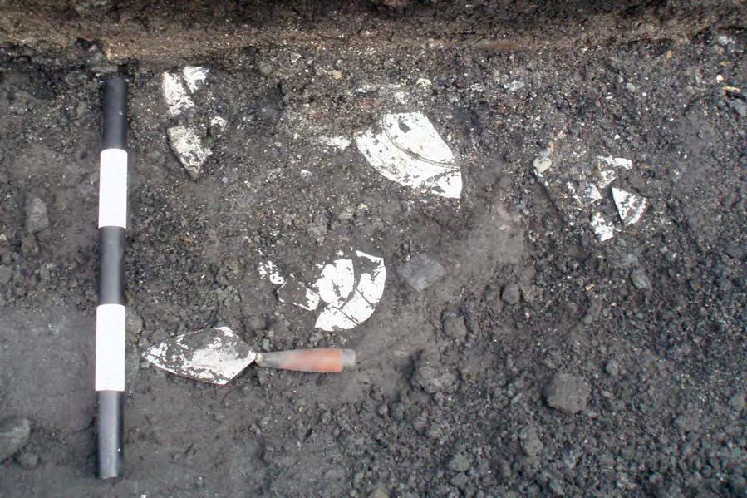
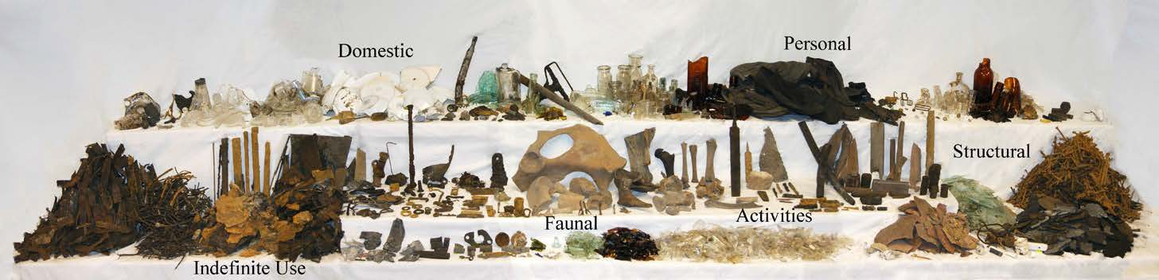
Artifacts from Downtown Seattle, Alaskan Way Viaduct (Upper Left and Lower) and Unknown Site (Upper Right)
Implement the IDP if …
You see strange, different, or interesting looking dirt, rocks, or shells.
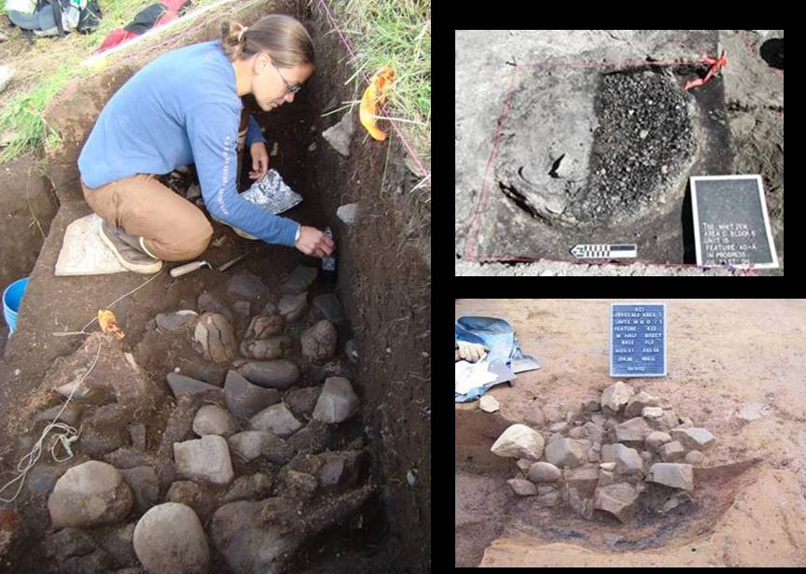
Unknown Sites
- Human activities leave traces in the ground that may or may not have artifacts associated with them
- “Unusual” accumulations of rock (especially fire-cracked rock)
- “Unusual” shaped accumulations of rock (e.g., similar to a fire ring)
- Charcoal or charcoal-stained soils
- Oxidized or burnt-looking soils
- Accumulations of shell
- Accumulations of bones or artifacts
- Look for the “unusual” or out of place (e.g., rock piles or accumulations in areas with few rock)
Implement the IDP if …
You see strange, different or interesting looking dirt, rocks, or shells.
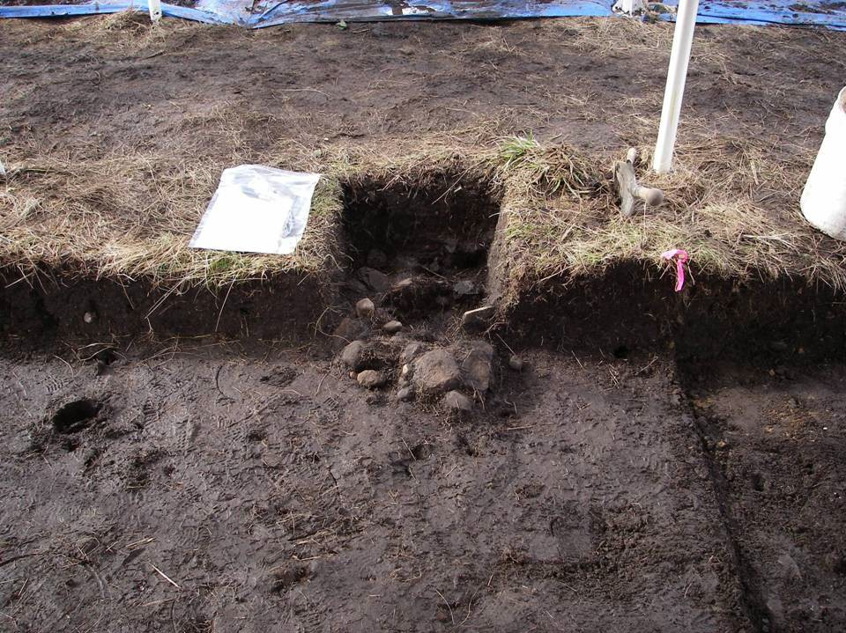
Site of Muckleshoot Indian Reservation, near WSDOT ROW along SR 164
- “Unusual” accumulations of rock (especially fire-cracked rock)
- “Unusual” shaped accumulations of rock (e.g., similar to a fire ring)
- Look for the “unusual” or out of place (e.g., rock piles or accumulations in areas with few rock)
Implement the IDP if …
You see strange, different or interesting looking dirt, rocks, or shells.
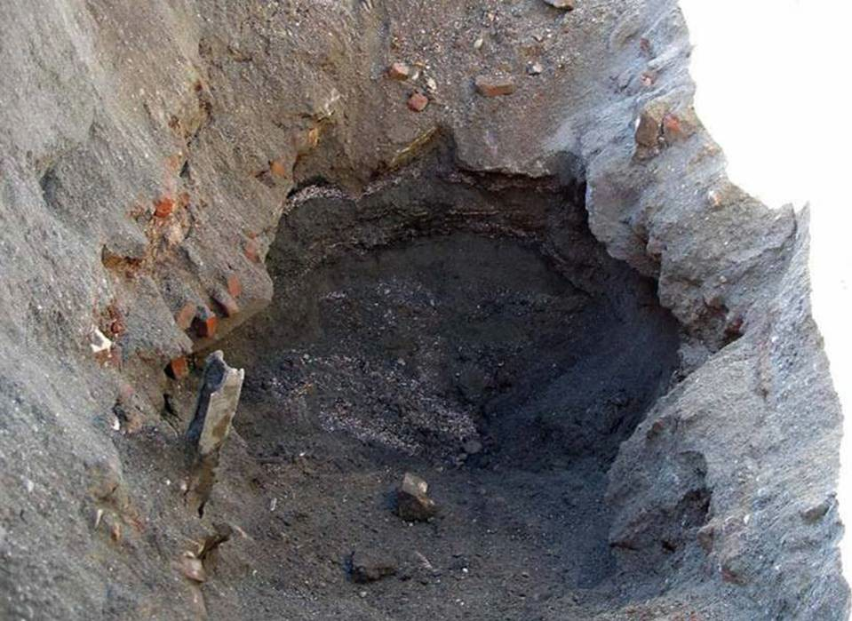
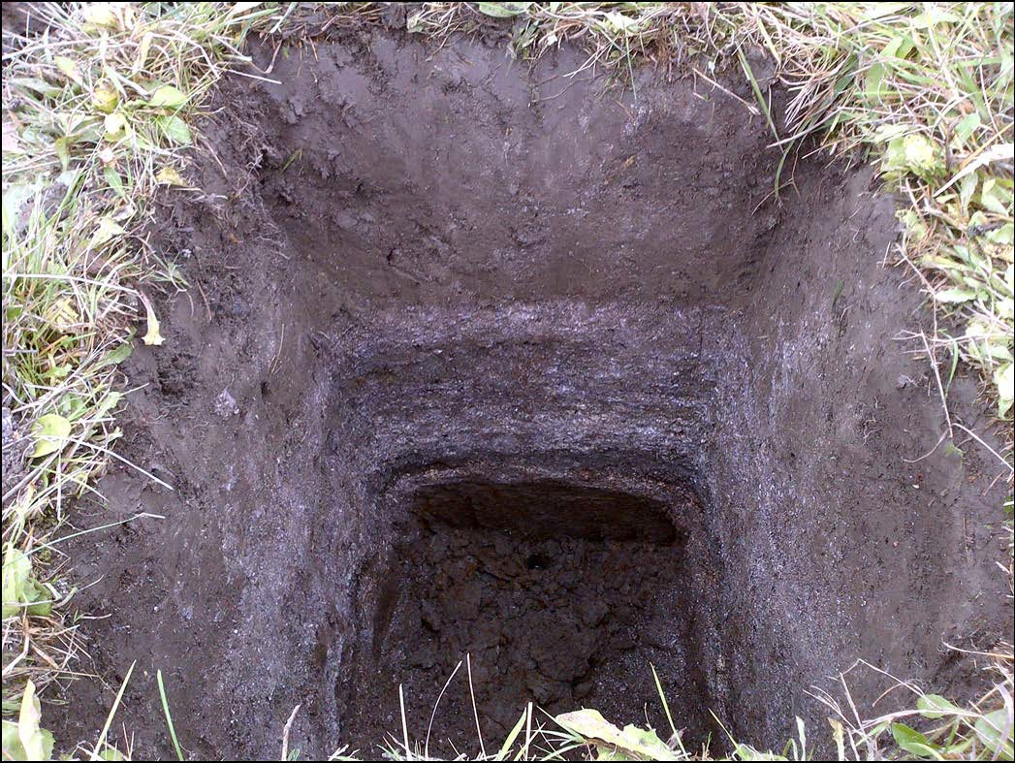
Site located within WSDOT ROW near Anacorles Ferry Terminal
Layers of shell midden
Historic debris
- Often have a layered or “layer cake” appearance
- Often associated with black or blackish soil
- Often have very crushed and compacted shells
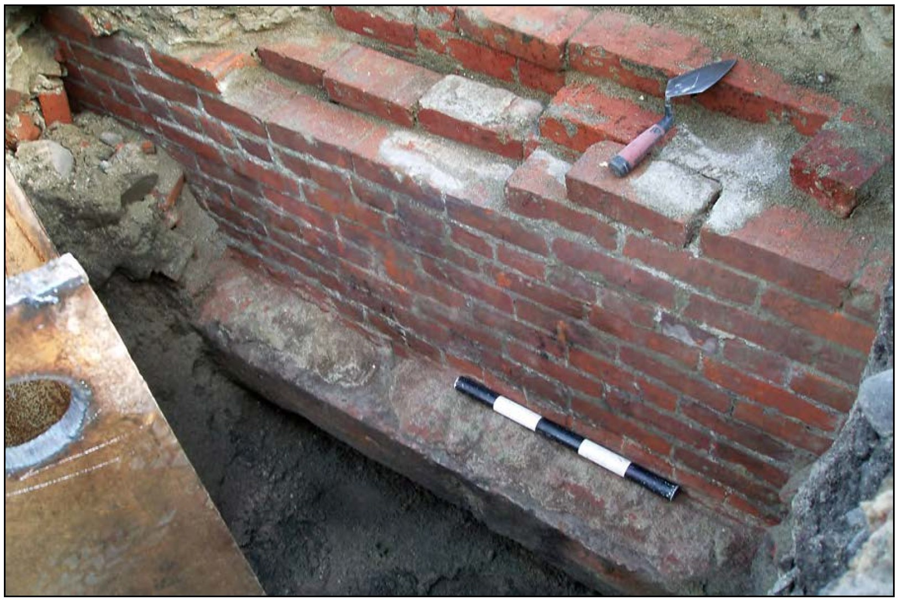
Implement the IDP if …
You see historic foundations or buried structures.
45KI1924, In WSDOT ROW for SR 99 Tunnel

Appendix C: Map of Project Area
Include any monitoring areas if applicable

