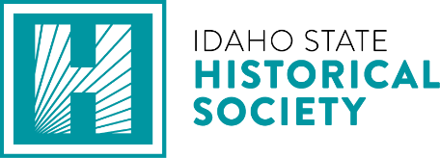

NOTICE OF MEETING
Per Idaho Code Idaho Code 74-202

April 8, 2026

To Whom It May Concern,

The Board of Trustees of the Idaho State Historical Society (ISHS) will be holding a Special Board of Trustees meeting on Thursday, April 9 beginning at 4:00 pm MT.

For any questions or inquiries, please contact the Administrative Office at (208) 334-2682.

